- The impact of the Middle East war on fuel prices entirely accounted for March’s jump in CPI inflation. We expect higher oil and gas prices, alongside some passthrough of firms’ higher input costs, to push inflation to 4%-4.5% in H2 2026. But the size of April’s annual regulatory price hikes will be a key influence on where inflation peaks during this period.
- Second-round effects of higher inflation on pay growth should exert some modest upward pressure on inflation in 2027. But base effects in the fuel and energy categories will drag inflation lower during the year.
CPI inflation increased to 3.3% in March, from 3% in February. The pickup was entirely driven by a sharp rise in the contributions from the fuel and energy categories, as upward pressure on oil prices from the Middle East war fed through to petrol and heating oil prices. RPI and RPIX both rose by 0.5ppts to 4.1% and 4% respectively.
Disruption to shipping through the Strait of Hormuz and damage to energy infrastructure will keep commodity prices elevated in the short-term. Therefore, petrol prices will remain high, while we expect the Ofgem energy price cap will rise by about 18% in July. Higher oil and gas prices will also raise input costs for other goods and services providers, some of which is likely to be passed on by firms. We expect these forces to push inflation up to 4%-4.5% in H2 2026, but the scale of April’s once-a-year increases for many index-linked contracts and regulated prices is notoriously difficult to judge and will be a key driver of where inflation peaks this year.
After that, we anticipate higher headline inflation will generate some modest second-round effects for services inflation via stronger pay growth in 2027. But powerful base effects caused by this year’s increases in fuel and energy prices will drag inflation lower during next year.
Chart 1: CPI inflation is forecast to average 3.9% in 2026 and 2.7% in 2027
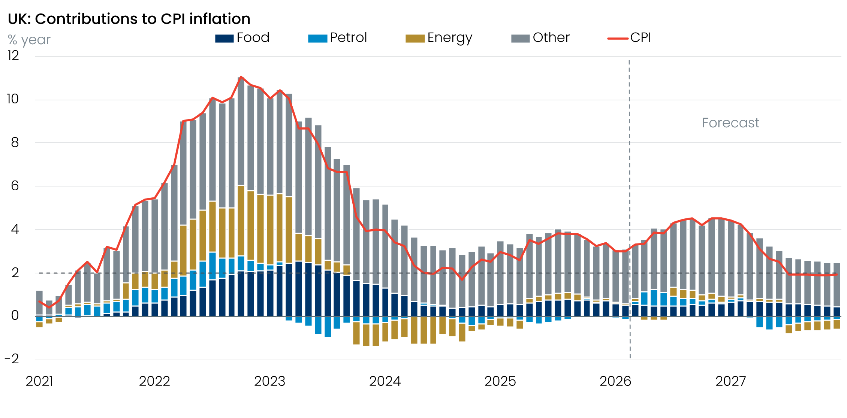
Sources: Oxford Economics, Haver Analytics

